**ASSIGNMENT – 9**

**ON: SUBQUERIES**

**Q1. Write a query to display the last name and hire date of any employee in the same department as Zlotkey. Exclude Zlotkey.**

|  |  |
| --- | --- |
| **LAST_NAME** | **HIRE_DATE** |
| **Abel** | **11-MAY-96** |
| **Taylor** | **24-MAR-98** |

Ans1.

SELECT LAST_NAME, HIRE_DATE

FROM EMPLOYEES

WHERE DEPARTMENT_ID = (SELECT DEPARTMENT_ID

FROM EMPLOYEES

WHERE LAST_NAME = 'Zlotkey')

AND LAST_NAME <> 'Zlotkey';

**Verification table -**

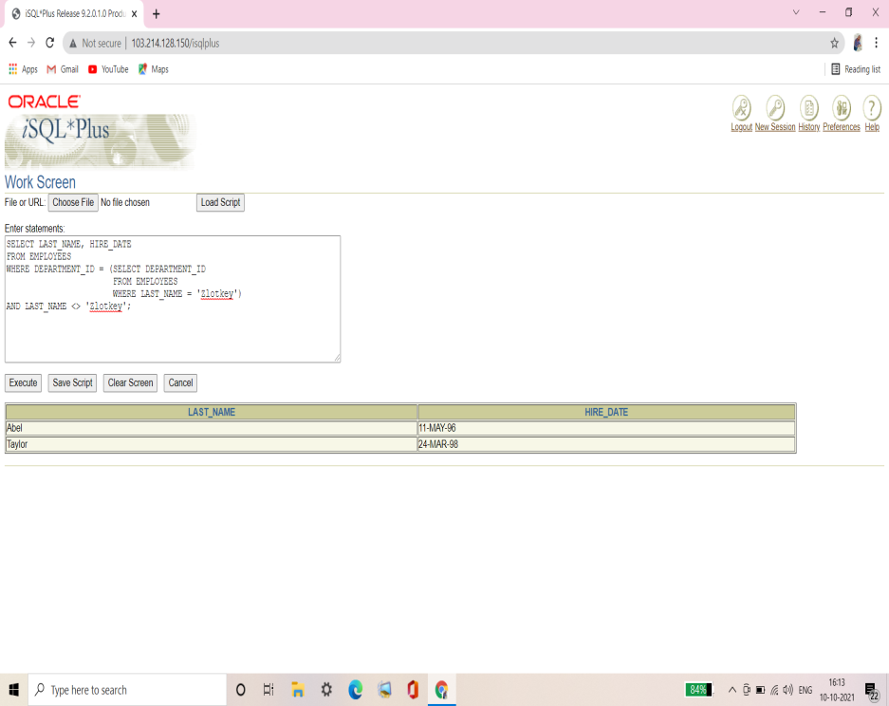

**Q2. Create a query to display the employee numbers and last names of all employees who earn more than the average salary. Sort the results in ascending order of salary.**

|  |  |  |
| --- | --- | --- |
| **EMPLOYEE_ID** | **LAST_NAME** | **SALARY** |
| **103** | **Hunold** | **9000** |
| **149** | **Zlotkey** | **10500** |
| **174** | **Abel** | **11000** |
| **205** | **Higgins** | **12000** |
| **201** | **Hartstein** | **13000** |
| **101** | **Kochhar** | **17000** |
| **102** | **De Haan** | **17000** |
| **100** | **King** | **24000** |

**8 rows selected.**

Ans2.

SELECT EMPLOYEE_ID, LAST_NAME, SALARY

FROM EMPLOYEES

WHERE SALARY > (SELECT AVG(SALARY)

FROM EMPLOYEES)

ORDER BY SALARY ASC;

**Verification table -**

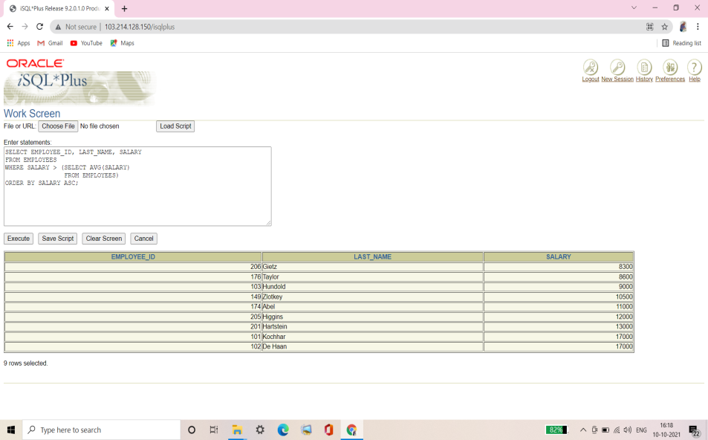

**Q3. Write a query that displays the employee numbers and last names of all employees who work in a department with any employee whose last name contains a u. Place your SQL statement in a text file named lab9_3.sql. Run your query.**

|  |  |
| --- | --- |
| **EMPLOYEE_ID** | **LAST_NAME** |
| **124** | **Mourgos** |
| **141** | **Rajs** |
| **142** | **Davies** |
| **143** | **Matos** |
| **144** | **Vargas** |
| **103** | **Hunold** |
| **104** | **Ernst** |
| **107** | **Lorentz** |

**8 rows selected.**

Ans3.

SELECT EMPLOYEE_ID, LAST_NAME

FROM EMPLOYEES

WHERE DEPARTMENT_ID IN (SELECT DEPARTMENT_ID

FROM EMPLOYEES

WHERE LAST_NAME LIKE '%u%');

**Verification table -**

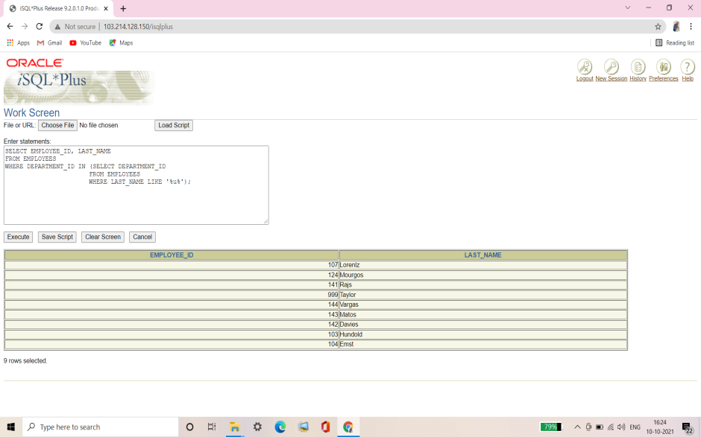

**Q4. Display the last name, department number, job ID of all employees whose department location ID is 1700.**

|  |  |  |
| --- | --- | --- |
| **LAST_NAME** | **DEPARTMENT_ID** | **JOB_ID** |
| **Whalen** | **10** | **AD_ASST** |
| **King** | **90** | **AD_PRES** |
| **Kochhar** | **90** | **AD_VP** |
| **De Haan** | **90** | **AD_VP** |
| **Higgins** | **110** | **AC_MGR** |
| **Gietz** | **110** | **AC_ACCOUNT** |

**6 rows selected.**

Ans4**.**

SELECT LAST_NAME, DEPARTMENT_ID, JOB_ID

FROM EMPLOYEES

WHERE DEPARTMENT_ID IN (SELECT DEPARTMENT_ID

FROM DEPARTMENTS

WHERE LOCATION_ID = 1700);

**Verification table -**

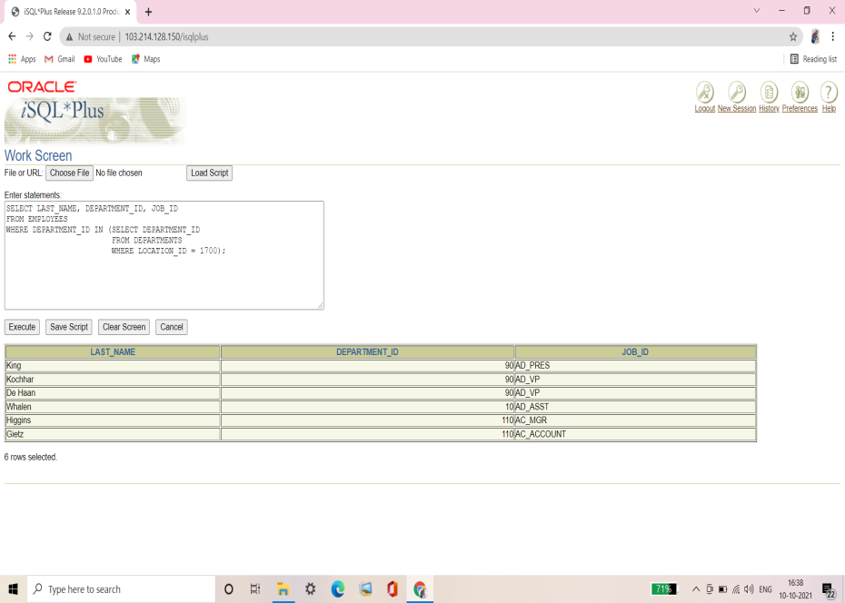

**Q5. Display the last name and salary of every employee who reports to King.**

|  |  |
| --- | --- |
| **LAST_NAME** | **SALARY** |
| **Kochhar** | **17000** |
| **De Haan** | **17000** |
| **Mourgos** | **5800** |
| **Zlotkey** | **10500** |
| **Hartstein** | **13000** |

Ans5.

SELECT LAST_NAME, SALARY

FROM EMPLOYEES

WHERE MANAGER_ID = (SELECT EMPLOYEE_ID

FROM EMPLOYEES

WHERE LAST_NAME = 'King');

**Verification table -**

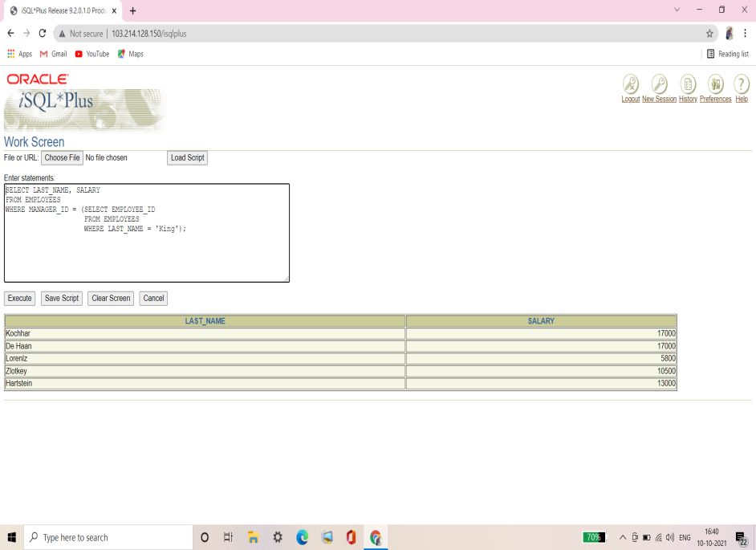

**Q6. Display the department number, last name, and job ID for every employee in the Executive department.**

|  |  |  |
| --- | --- | --- |
| **DEPARTMENT_ID** | **LAST_NAME** | **JOB_ID** |
| **90** | **King** | **AD_PRES** |
| **90** | **Kochhar** | **AD_VP** |
| **90** | **De Haan** | **AD_VP** |

Ans6.

SELECT DEPARTMENT_ID, LAST_NAME, JOB_ID

FROM EMPLOYEES

WHERE DEPARTMENT_ID = (SELECT DEPARTMENT_ID

FROM DEPARTMENTS

WHERE DEPARTMENT_NAME = 'Executive');

**Verification table -**

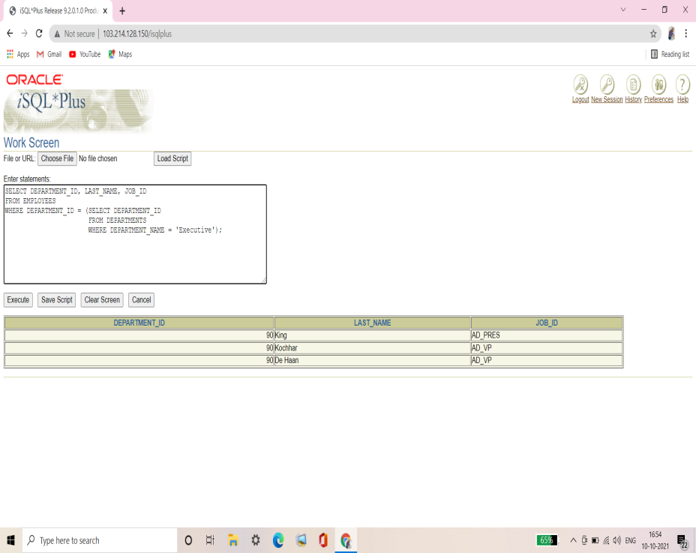

**Q7. Modify the query in lab9_3.sql to display the employee numbers, last names, and salaries of all employees who earn more than the average salary and who work in a department with any employee with a u in their name. Resave lab9_3.sql to lab9_7.sql. Run the statement in lab9_7.sql.**

|  |  |  |
| --- | --- | --- |
| **EMPLOYEE_ID** | **LAST_NAME** | **SALARY** |
| **103** | **Hunold** | **9000** |

Ans7.

SELECT EMPLOYEE_ID, LAST_NAME, SALARY

FROM EMPLOYEES

WHERE SALARY > (SELECT AVG(SALARY)

FROM EMPLOYEES)

AND DEPARTMENT_ID IN (SELECT DEPARTMENT_ID

FROM EMPLOYEES

WHERE LAST_NAME LIKE '%u%');

**Verification table -**

